DEMONSTRATE AN UNDERSTANDING OF THE PRINCIPLES OF THE INTERNET AND THE WORLD-WIDE-WEB
UNIT STANDARD ID: 115391
NQF LEVEL: 4
CREDITS: 3
NOTIONAL HOURS: 30



ASSESSMENT INSTRUMENT

Name | Mila Mihlali Ngewu
Contact Address | ngewumila007@gmail.com
Telephone (H)
Telephone (W)
Facsimile
Cellular | 082 365 5804

Instructions to learner

- You must complete the classroom activities whilst facilitation is taking place. The facilitator may stop at regular intervals to give you time to complete the activities.
- Please complete all work in blue or black pen. The assessor will not assess the evidence if completed in pencil.
- You are not allowed to copy from another learner. Any plagiarism committed will be viewed in a serious light and disciplinary action may be taken against you. Your work must be authentic i.e. your own work. Group work is allowed in certain activities but your answers must be your own original work after discussions in the group.
- You must sign the declaration contained in the assessment preparation and planning document declaring that all work is your own. If you so not sign this declaration, the assessor will not proceed with assessment and your results will be delayed.
- Please do not use any correction fluid i.e. tippex. Rather cross your work out and write next to your mistakes.
- The proficiency level required for each unit standard in the cluster is 50% per specific outcome per unit standard. If you are deemed Not Yet Competent in a unit standard, you will only be required to redo (remediate those sections in that unit standard.
- Any remediation must be submitted within 30 working days after you gave received feedback
- For practical assessments you need a computer, Ms Office and the assessor
- Answer section A and Section B

Assessment Process Flow
Assessment Plan agreed by candidate & completed by the assessor before the actual assessment
Knowledge Questionnaire conducted as per the Assessment Plan
Observation conducted as per the Assessment Plan
Portfolio of Evidence compiled as per the Assessment Plan

A detailed Assessor Report compiled & forwarded for Moderation
Record of Learning Updated
Appeal form completed by the candidate in the event of dispute
Feedback Report Completed by Assessor & individual feedback given to the candidate
Assessment Results Moderated
Action Plan Completed by Assessor
All records & evidence filed
Completed Assessor Report / Moderator Report / Record of Learning
Approval & Certification obtained
Certificate of Competencies issued to successful candidates
Register candidates on the Learner Record Database
Portfolio of Evidence submitted as per the Assessment Plan

CAND
I
DATE
ASSESSMENT
SETA

Agreed Assessment Plan

Candidate's Name:
Assessor's Name:
Standard Title: | Demonstrate an understanding of the principles of the internet and the world-wide-web
EVENT | DATE, TIME AND LOCATION | RESOURCES REQUIRED | EVIDENCE TO BE GENERATED
Attend Training |  | Training material, equipment as specified | Attendance Register
Complete formative assessment |  | Formative workbook | Completed formative workbook
Complete summative assessment |  | Summative workbook | Completed knowledge questionnaire

Signature of Candidate: ______________________________ Signature of Assessor: ______________________________

Date: ______________________________
SECTION A: FORMATIVE ASSESSMENT

Question 1 (SO 1, AC 1, AC 2, AC 3, AC 4)
Discuss the principles of the internet and world-wide-web. In your discussion explain the following;
- Origins and history of internet.
- Major applications of the internet.
- Major internet applications.
- History and development of world-wide-web. (20)
Origins and history of the internet:

When developers first began to see the potential of computers for sharing information on specialized military studies in the 1960s, the internet was born.
In 1965, Lawrence Roberts of MIT linked a computer in Massachusetts with one in California via dial-up telephone connections. This demonstrated the potential of wide area networking and even the inadequacy of telephone circuit switching. Roberts moved to DARPA in 1966 to create his ARPANET strategy. When ARPANET went live in 1969, the dream was made a reality.
Major applications of the internet:
Social Media.
Web Browsing.
Real-Time Update.
Online Shopping.
Communication.
Major internet applications:

Web Browsers: Applications like Google Chrome, Mozilla Firefox, and Microsoft Edge enable users to
access websites and online content.
Email: Services like Gmail, Outlook, and Yahoo Mail are widely used for sending and receiving emails.
Search Engines: Google, Bing, and Yahoo are popular search engines for finding information on the
web.
Social Media: Platforms such as Facebook, Instagram, Twitter, LinkedIn, and TikTok facilitate social
networking and content sharing.
History and development of world-wide-web:
The development of the Transmission Control Protocol (TCP) and the Internet Protocol (IP) in the 1970s provided a standardized way for different networks to communicate with each other, forming the foundation for the internet.
In 1983, ARPANET officially switched to using TCP/IP, marking the birth of the modern internet.
The late 1990s saw a massive growth in internet-related businesses, leading to the dot-com boom. Companies like Amazon, Google, and eBay emerged during this time.
This period also witnessed the development of broadband internet connections, enabling faster access to online content.
The 2000s saw the proliferation of mobile devices and the development of mobile internet, enabling people to access the web on their phones and tablets.
Web 2.0 technologies, characterized by user-generated content and interactive web applications, became prominent. Social media platforms like Facebook and YouTube gained widespread popularity.

Question 2 (SO 2, AC 1, AC 2, AC 3)
Explain how the world-wide-web incorporates the various internet applications. In your explanation;
- Provide a comprehensive understanding of physical context of web pages
- Identify how the word-wide-web can be applied in an intranet and extranet.
- Describe the latest internet application, including web-based email, instant messaging and voice-over-IP (VoIP). (20)

The World Wide Web users to access a wide range of information and services. This is how it
Incorporates internet application.
Hypertext and Hyperlinks:
The notion of hypertext, which enables documents (web pages) to be connected by hyperlinks, is the
foundation of the World Wide Web. These links can be clicked on to access other web pages,
documents, photos, videos, or other online content. They are clickable elements within web pages. By
clicking on links, users can access many types of information and resources on the web with ease.
Web Servers:
The devices or software used to host and deliver web content to consumers are known as web servers.
Your browser sends a request to the relevant web server when you type in a web address (URL), and
the server responds by providing your browser the requested web page or resource. Web servers are
essential for providing content and applications from the internet to users all over the world.
The physical context of web pages refers to the various elements and factors that contribute to the way a
web page is displayed and interacted with on a user's device or browser.
Small smartphone screens and huge desktop monitors both have different screen sizes and resolutions.
In order to offer a consistent user experience, web sites should adjust to these variations.
The portion of a web page that is visible in the browser window is called the viewport. Designers must
take this viewport into account when creating content, especially for mobile devices with
constrained screen sizes.
how the word-wide-web can be applied in an intranet and extranet.
Application in intranet:
Information sharing within an organization: An intranet is a private network within a company. Internal websites and web-based apps for communicating crucial information, like as policies, processes, employee handbooks, and announcements, can be created via the web and intranets. By doing so, you may increase communication and guarantee that your staff has access to the most recent information.
Web-based collaboration tools such as wikis, discussion forums, and project management systems are
frequently used in intranets. These technologies make it simple for staff members to discuss ideas,
share documents, and work together on projects.
Application in Extranet:
Collaboration between partners and vendors: Extranets open up the web to suppliers, partners, and other external stakeholders. They can be used to build secure portals that permit authorised external parties to share resources, work together on projects, and access pertinent data.
Client Access: Extranets can enable organizations to provide clients with secure access to specific data and services. For example, a law firm might create an extranet portal for clients to view case documents and updates.
Latest internet application, including web-based email, instant messaging and voice-over-IP (VoIP).
This is how the internet applications have evolved at this day and age
- Web based Email
- Enhanced security: Security features in web-based email services have gotten better over time. To safeguard user data and privacy, end-to-end encryption and multi-factor authentication (MFA) have grown in popularity.
- AI-Powered features: Features Powered by AI: Machine learning and artificial intelligence are being used to improve spam filtering, classify emails, and even create responses. Users benefit from time savings and inbox organization from these capabilities.
- Instant Messaging:
- End-to-end Encryption: Instant chat apps continue to place a high priority on security and privacy. Messages are only accessible to the intended recipients thanks to end-to-end encryption.
- Group Chat and Collaboration: Larger group support has been added to group chat capabilities, making it simpler for communities and teams to work together.
- Voice-over-IP(VoIP)
- High-Quality Audio and Video: VoIP services offer high-quality audio and video calls, often in HD or even 4K resolution, providing a more immersive communication experience.
- Conference Calling: VoIP services frequently support conference calls with multiple participants, making them valuable tools for business meetings and remote collaboration.

SECTION B: SUMMATIVE ASSESSMENT

Answer the following tasks

Task 1 (SO 2, AC 1)
You are required to visit any 3 web page on the internet. Explain the physical context of the web pages.
- The first website I decided to visit is LottieFiles: this website specializes in animations for app development and for presentations.
The physical feel of this website in my words: It is a very good responsive website that automatically adjusts its size according to the screen size.
It has the ability to change its own layout accordingly this thus makes it very convenient to use regardless of the type of device one uses.
This is the hyperlink that leads to the website: https://lottiefiles.com/
Bellow is the screenshot of the home page:


2.The second website I decided to visit is YouTube.
I be live this one serves as a very good example of how the use of video media can be incorporated on the internet. This like the other site I mentioned above also has a very good responsive ability to many different screen sizes including the videos on the site, not to mention its abilities to change the video quality according to the size and the speed of the internet one uses as well.
Hyperlink https://www.youtube.com/
Screen picture: 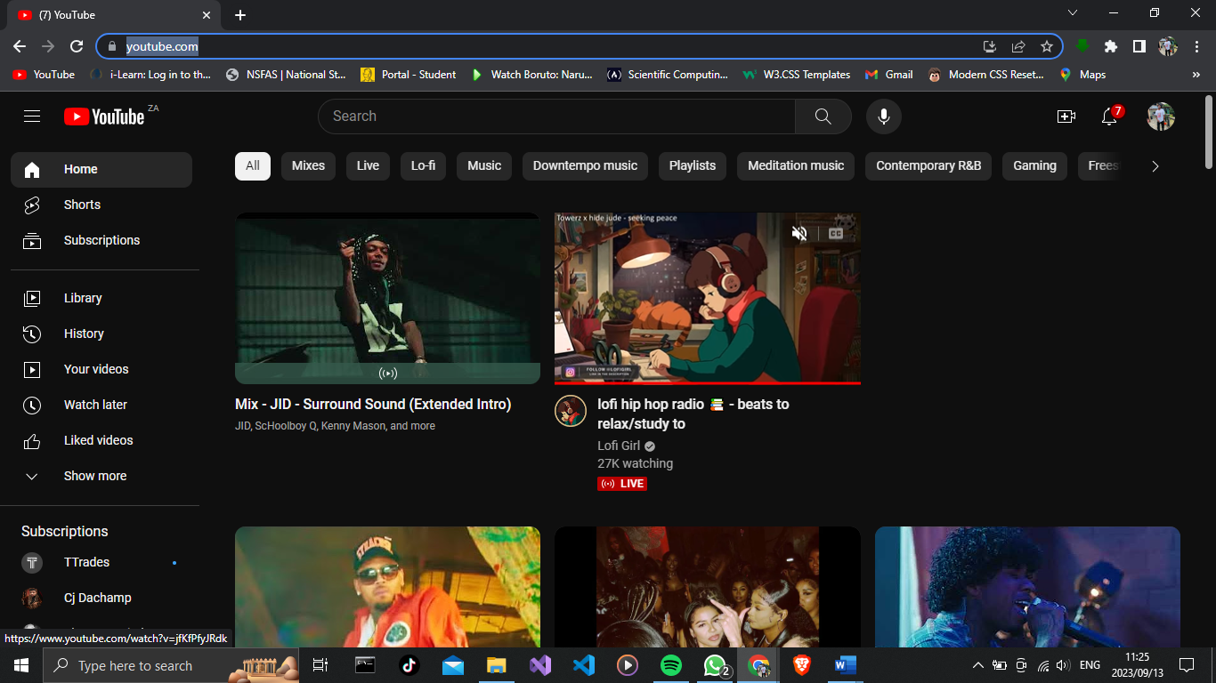

3. Spotify:
I chose this one because of their abilities to transfer audio over the internet to various devices even to extents of sharing the same audio over different devices on the same network (WiFi).
Its user interface is one of the best interfaces I have ever seen on the internet and it is so easy to navigate over it(not that one needs to do a lot of navigating given the amazing music suggestions they make for a user depending on the type of music they like).
HyperLink: https://www.spotify.com/
Photo:
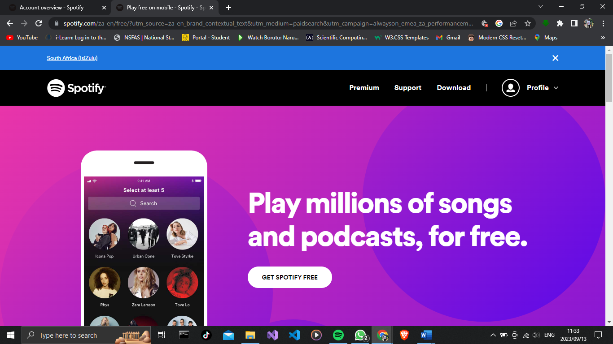
(8)

NOTE: attach a copy of the web pages in your POE.

Task 2 (SO 1, AC 2, SO 2, AC 3)
You are required to collect 3 newspaper or internet articles that talk about internet applications. Complete the following tasks using the articles;
- Summarise the articles.
- Identify the internet applications that where discussed and explain when you can use them in your personal life or work context. (15)

Article 1: Self-adaptive architectures in IoT systems: a systematic literature review

In recent years, IoT's significance has grown, impacting both industry and daily life. IoT systems face challenges from dynamic environmental changes, affecting Quality of Service (QoS). Existing adaptation strategies address specific changes, lacking a holistic view. This paper reviews IoT adaptation studies, outlines dynamic events' interplay, QoS implications, and suggests a research agenda.

Communication: enables information transmission and communication to enable novel forms of interaction between objects and humans.
Communication has become so much easier these days. The internet allows us to simply contact our friends and loved ones in a matter of seconds no matter how far they may be.

Improved daily tasks: The Internet of Things has changed and enhanced the daily tasks we perform in a number of areas, including transportation, agriculture, healthcare, industrial automation, and emergency response.
I would like to talk more about Transportation, It is so much easier to navigate to ones destination without even the need to know the area through the help of GPS services, this can be very good for transportation as it saves a lot of time.

Self-Adaptive Systems: For many years, self-adaptive systems have been investigated. Stages in the evolution of self-adaptive systems are categorized by Wong et al . The authors presented a theoretical model of self-adaptive systems during the initial period (1990–2002).
The use of DHCP has proven to be one of the best self-adaptive systems hence it enables devices to autoconfigure themselves without the need for network technicians.
Article by Ivan Alfonso, Kelly Garces, Harold Castro & Jordi Cabot
Posted on Sprinter Open. https://jisajournal.springeropen.com/articles/10.1186/s13174-021-00145-8

Article 2: Wikipedia Diversity Observatory project

This article introduces the Wikipedia Diversity Observatory project, designed to enhance content diversity on Wikipedia. It offers visual dashboards and tools highlighting content gaps, including topic imbalances and concept variations across language editions. The project labels articles by geography, gender, and other categories to promote diversity. Examples illustrate how these tools assist editors in addressing content gaps, with a focus on the project's impact on the Wikimedia movement's strategic diversity efforts.

Topical coverage of Wikipedia is the result of the interplay of factors including editors’ motivation:
This access has allowed so many from different places to share and help with informative content. This also helps a lot of writers to share their work and build their credibility on the internet.
quality content preferences: This gives viewers so many options to consume from rather than a controlled system by a particular group. This allows so many different views to be shared with no biased formation.
Article by Marc Miquel, and David Laniado
Posted on Springer Open: https://jisajournal.springeropen.com/articles/10.1186/s13174-021-00141-y#Abs1

Article 3: decentralized autonomous organizations in the Ethereum blockchain

Blockchain technology has expanded beyond finance, paving the way for novel governance systems like Decentralized Autonomous Organizations (DAOs). DAOs use decision-making mechanisms enabling online communities to reach agreements, allowing automatic execution of code for tasks like hiring, payments, and investments. Platforms like Aragon, DAOstack, and DAOhaus facilitate DAO creation, leading to a proliferation of these organizations. This paper examines the DAO ecosystem by reviewing and comparing the main platforms. Using quantitative metrics and data from Ethereum networks, the study analyzes 72,320 users and 2,353 DAO communities across dimensions like growth, activity, voting, and funds. Findings highlight platform differences and underscore the need for further research on decentralized governance achievement.

Due to its origins linked to cryptocurrencies, blockchain has been mostly applied to financial applications. However, in recent years it is increasingly applied to other fields. This enables users to make international transactions without the need for swift.
The advent of new, blockchain-mediated decentralized governance models is a particularly intriguing application. These blockchain-enabled businesses are referred to as Decentralized Autonomous Organizations (DAOs), and they make use of the benefits that the blockchain infrastructure offers to enable things like formalized rules, automated processes for some tasks, and purported decentralization of power.
Article by Youssef Faqir-Rhazoi, Javier Arroyo and Samer Hassan
Posted on Springer Open: https://jisajournal.springeropen.com/articles/10.1186/s13174-021-00139-6

ASSESSMENT DECISION & EVIDENCE EVALUATION RECORD
Candidate's Name: -

Assessor's Name: -

Formative assessment
I declare that this assessment is my own work.

Marks: The learner is either “Met requirements” or “Did not meet requirements”. If the learner did not meet requirements in an area, then he or she must be reassessed.
Learner achieved: Competent/Not yet competent
Overall outcome:

Note: When learner do practical assessments ensure that they meet the overall outcome.

Specific Outcome – AC |  | Met requirements | Did not meet requirements | Comments
1

Specific Outcome |  | Met requirements | Did not meet requirements | Comments
 | Specific Outcome – AC | Met requirements | Did not meet requirements | Comments
 | Specific Outcome – AC | Met requirements | Did not meet requirements | Comments
 | Specific Outcome – AC | Met requirements | Did not meet requirements | Comments

OVERALL ASSESSMENT DECISION

Assessors Comments:

Signature of Assessor:

Date:

